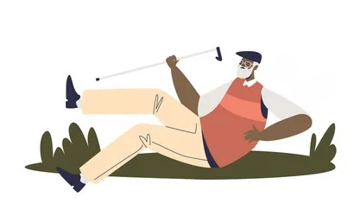

***September 2024***

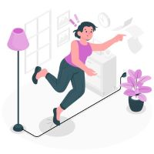

**Did you know that in Hawai’i, 55,588 Kupuna reported a fall in 2020?**

Studies show that many people, who experience a fall, become afraid of falling. This fear can cause a person to cut down on activities. Being less active can actually make a person increase their chances of falling.

Our risk of falling increases as we age. 1 in 4 adults between the ages of 65-80 report a fall. Reported falls from adults over the age of 80 is 1 in 3.

Each year, an estimated 8 million older adults receive an injury from a fall. Over 3 million older people are treated in emergency departments for fall injuries and over one million are hospitalized because of fall related injuries.

In 2022, 40,919 older adults aged 65, older died from preventable falls, and over 3.5 million were treated in emergency rooms after a fall.

Thankfully, many people who fall do not suffer from a serious injury, but one out of five falls does result in serious injury.

Falls can be serious. A fall that results in an injury can decrease one’s ability to remain safely in their home.

*The information below was obtained from the Center on Disease Control (CDC). The information from the CDC shows that millions of people over the age of 65 suffer a fall each year.*

*Why Fall Prevention Matters*

**For more information on Fall Prevention please visit the following websites:**

National Council on Aging [www.ncoa.org](http://www.ncoa.org) Administration on Community Living [www.acl.gov](http://www.acl.gov) Hawai’i County Office of Aging [www.hcoahawaii.org](http://www.hcoahawaii.org) Center for Disease Control [www.cdc.gov](http://www.cdc.gov)

National Institute on Aging [www.nia.nih.gov](http://www.nia.nih.gov)

*Not so fun facts about falls*

Risk factors may be health related:

Poor vision, vitamin or nutrition deficiency, dehydration, medication side effects, illness.

It is important to share concerns about your mobility, medications, sleep patterns, energy level, aches and pains with your family and medical team.

*It is important to be aware of factors in your life that may increase your risk of falling. Making changes to these risks can help you stay on your feet.*

*Decrease risk factors to help decrease your chances of falling*

***Pay Attention to Fall Prevention***

**National Fall Prevention Week Sept. 23 – 27th**

*Being proactive about Fall Prevention can help you stay safe and healthy in your home and community!*



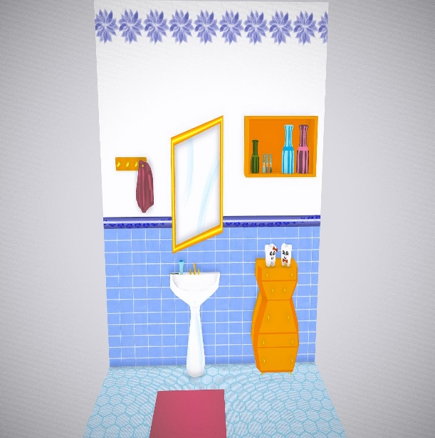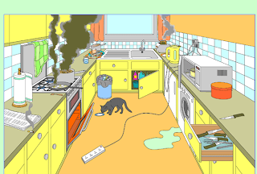

**Rooms/Main areas**

Have a clear walking path to rooms.

Keep electrical cords clear of walkways.

Keep rooms well lit.

Use nightlights in rooms and hallways.

Keep walking spaces clear from clutter.

Make sure rugs lay flat; use a nonslip mat under rug to reduce movement of rug.

**Bathroom**

Keep bathroom area clear from clutter.

Install grab bars in shower/bath.

Use nonslip flooring/anti-slip strips on bathroom flooring and shower/bath areas.

Use toilet rails for balance.

Use a shower bench/chair in bath area.

Wear fall detection device when in the bathroom.

*The bathroom is the room in our homes where many falls occur. Having a safe bathroom to fit your needs is important in the goal of decreasing your risk for falls. Many items can be installed in your bathroom to increase your safety. Utilizing grab bars in your shower, bath and toilet area can help you stabilize yourself and non-slip flooring reduces the risk of slipping in wet areas.*

*Bathroom Safety*

***How many fall risks are in the picture above?***

**Kitchen**

Keep commonly used dishes and cooking wear in an easy to access area/cabinet/shelf.

Use a step stool with handles if needed to reach high items.

Make sure chairs and stools are in good condition and used only for sitting.

Keep chairs pushed in under tables to avoid hitting them or tripping over the legs.

Wipe up spills immediately

Keep commonly used food items in easy to reach areas.

**Bedroom**

Keep your walkway clear from the bed to the door.

Have an easily accessible light source to use if needed at night.

Keep sharp furniture edges away from your bed.

Keep your assistive devices close to your bed for easy access when needed.

Before getting out of bed, take a minute to sit on the bed before standing up.

**Stairs**

Make sure stairs are in good repair.

Clean stairs regularly to remove dust, dirt, algae growth.

Place adhesive anti-slip strips on stairs to avoid slippage.

Install/use handrails to help maintain balance when using stairs.

*This checklist can help you ensure your home is set up safely to help prevent a fall. It is always wise to check your home for safety a few times a year to make sure hazards are removed.*

*Home Safety Tip Checklist*

***Getting Up Safely From a Fall***

***ask the experts >>>***

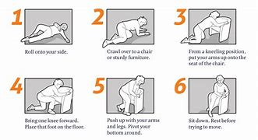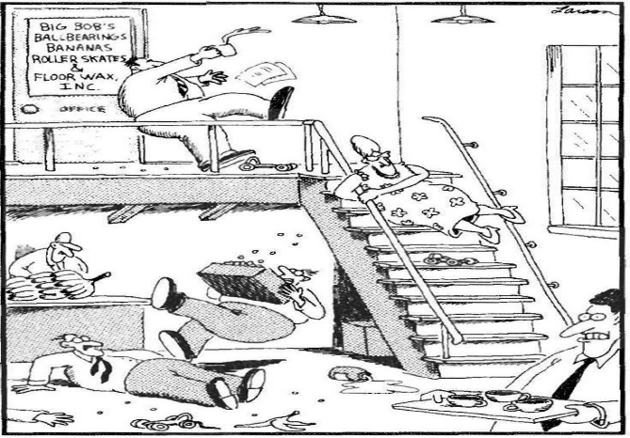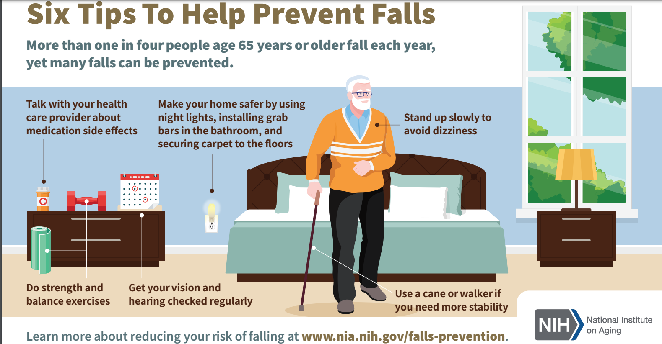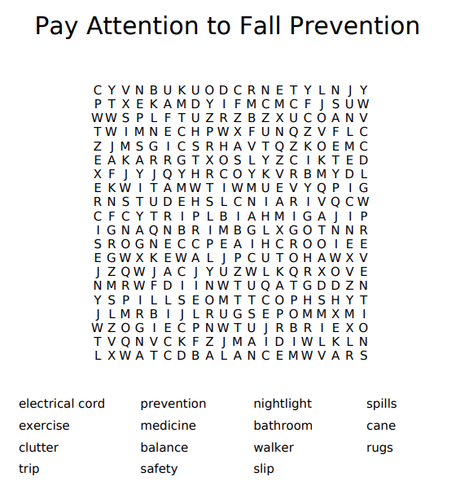

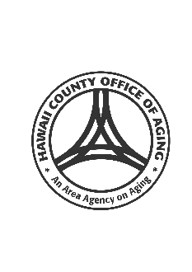[](https://www.layoutready.com/?utm_source=microsoft&utm_medium=file&utm_campaign=office_online)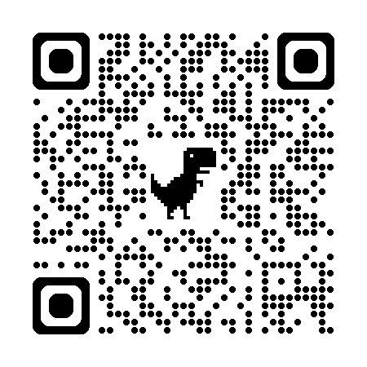

1055 Kinoole St. Suite 101

Hilo, HI. 96720

**Hawai’i County Office of Aging**

Contact us to schedule a Fall Prevention Training @ 808-961-8626www.hcoahawaii.org

*Scan the QR code above to watch our Fall Prevention Tips and Awareness video featuring HCOA, ADRC, Alz. Association, Public Health Nursing and Hawaii County Fire Department.*

***Fall Prevention Video***

**Fall Prevention Tips**

* **Remove hazards from your home and yard**
* **Stay active and exercise**
* **Wear sensible and safe footwear**
* **Have vision checked regularly**
* **Use handrails when using stairs**
* **Review medications with your doctor**
* **Share your concerns about falling with others**
* **Use recommended equipment (walker, cane)**

*This newsletter is brought to you by the Hawai’i County Office of Aging/Aging and Disability Resource Center. We hope you take some time to read the information provided and make some changes to help prevent you from having a fall. Mahalo*

*Pay Attention to Fall Prevention*

*Finding An Agent That’s Right For You*